Accessing User Authentication service through Zuul proxy:

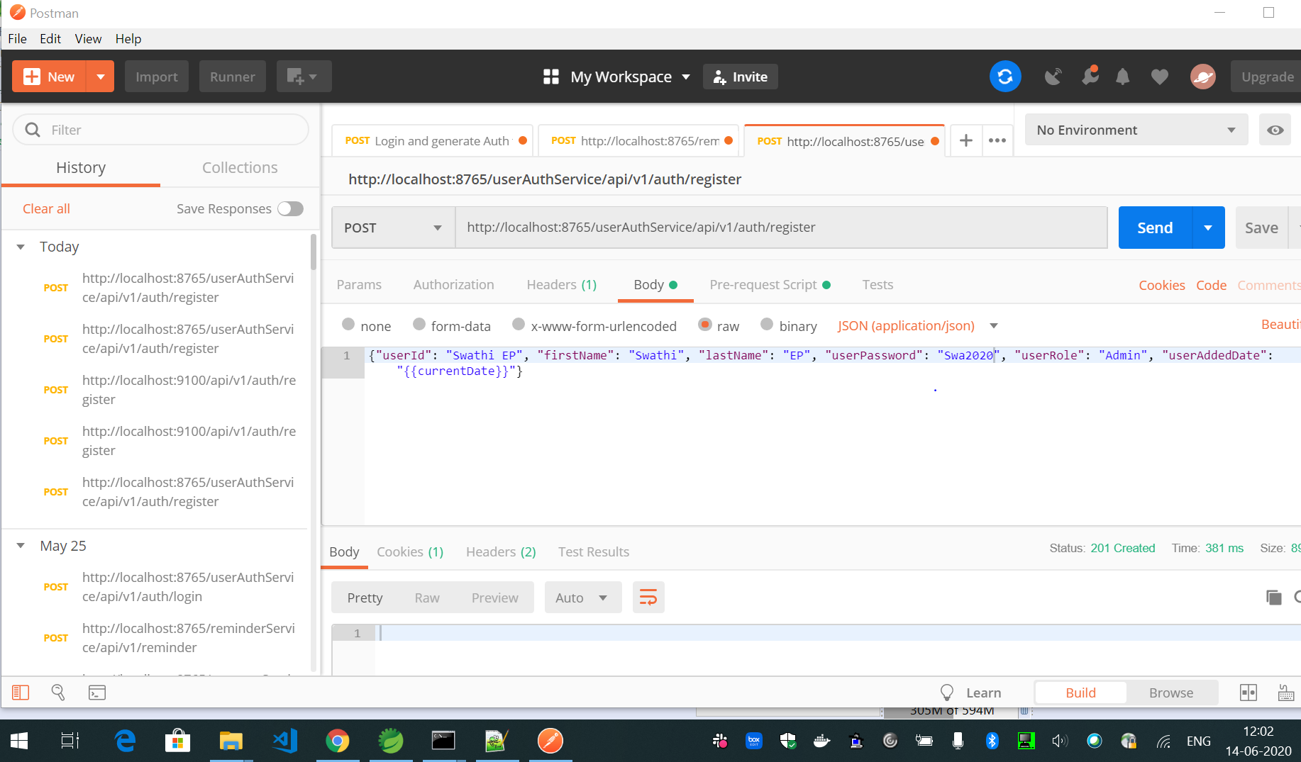

Login using registered user through zuul proxy:

JWT token generated is returned in the login response.

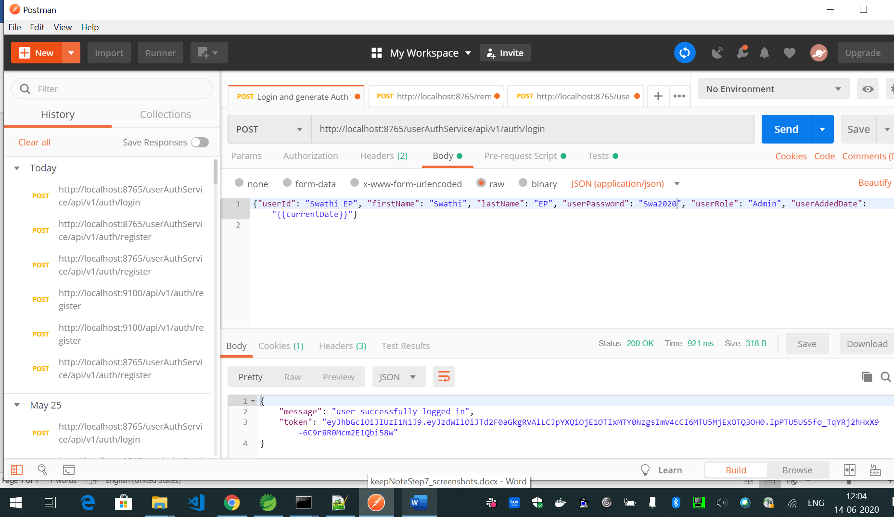

Generate Docker image userauth-service:

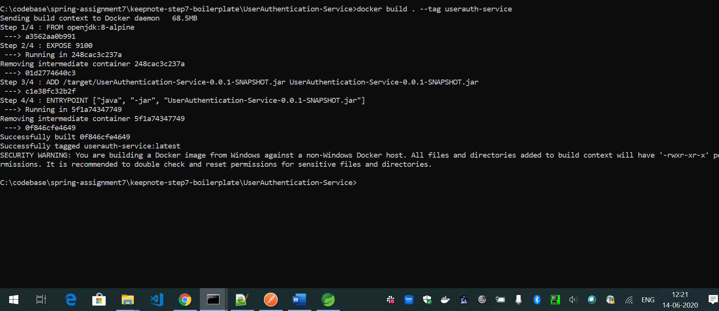

Created Image is listed in the list:

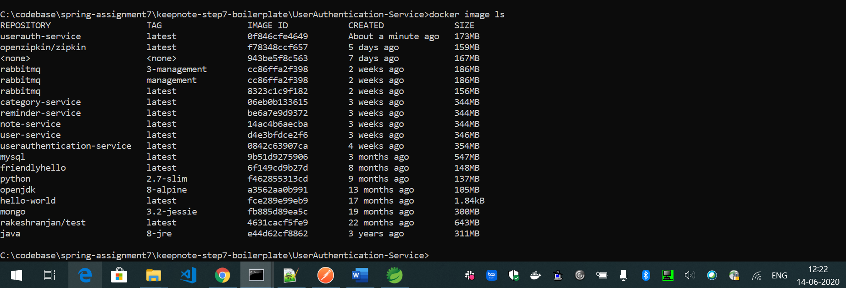

Zipkin Trace id:

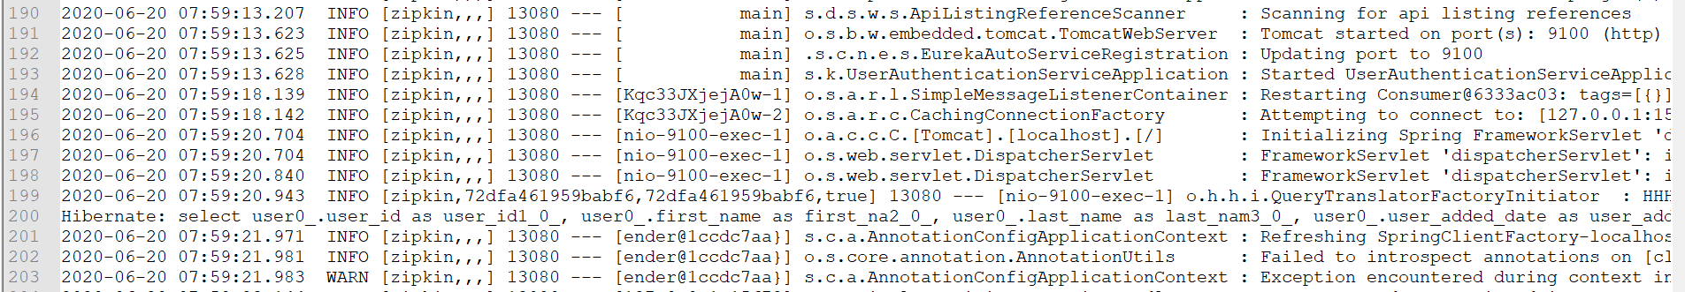

Creating user in MongoDb using UserService with Authorization header through zuul proxy:

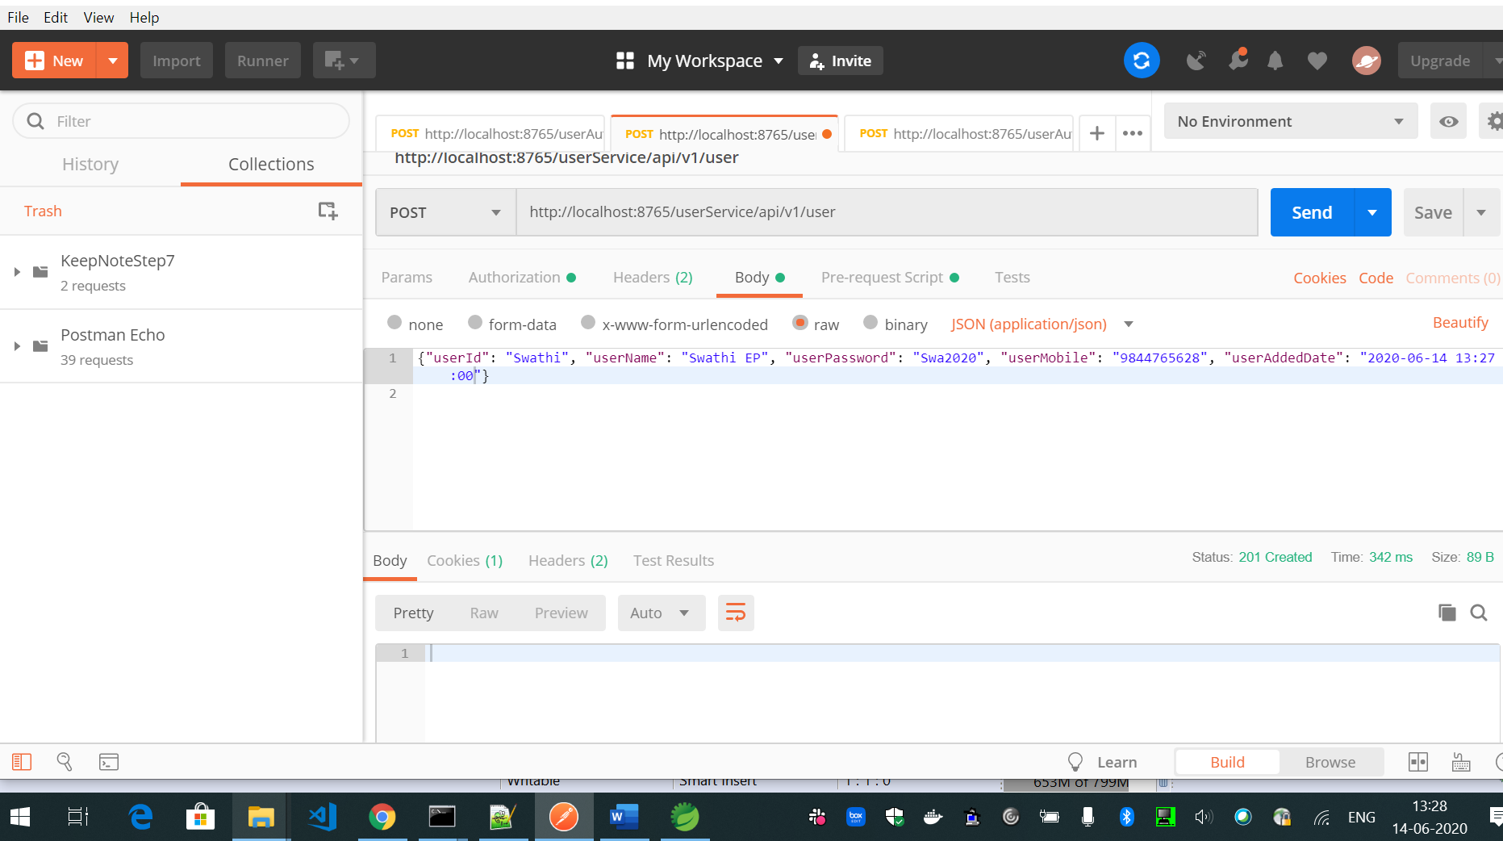

Accessing update user api of UserService with Authorization header through zuul proxy:

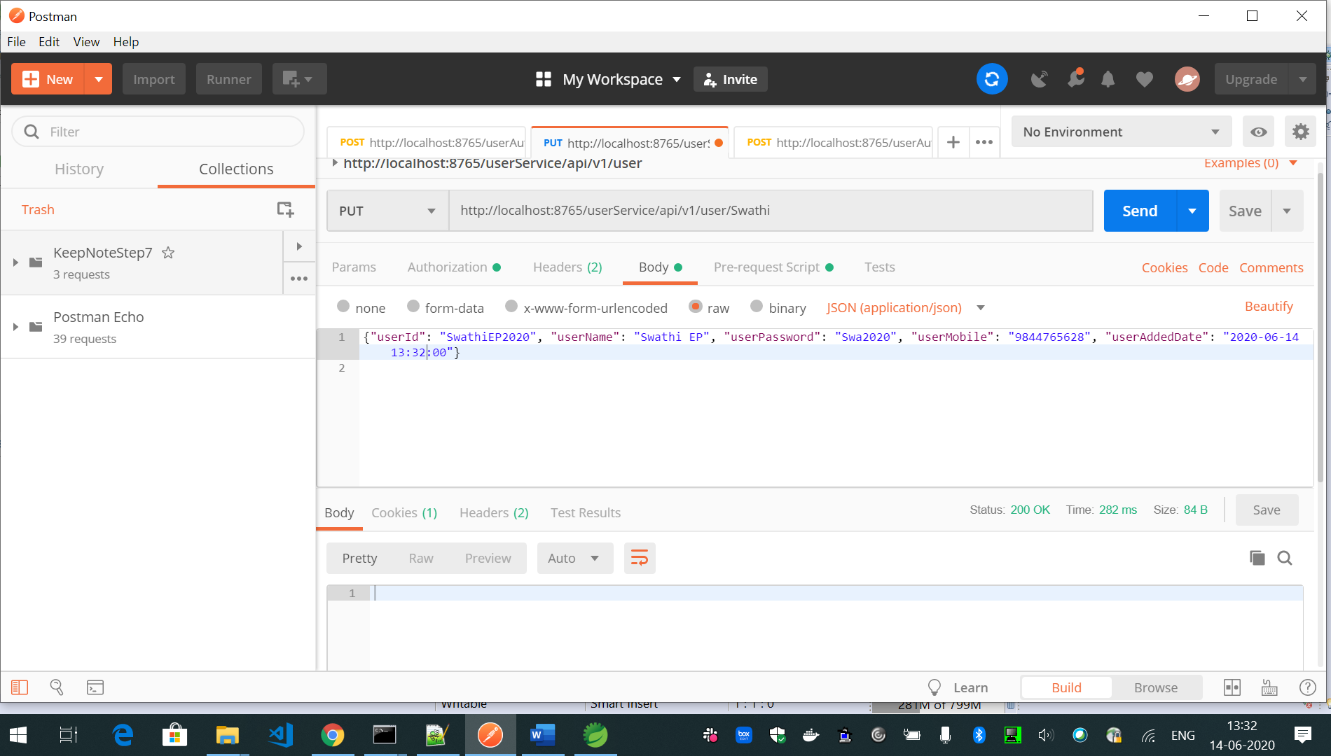

Docker build user service:

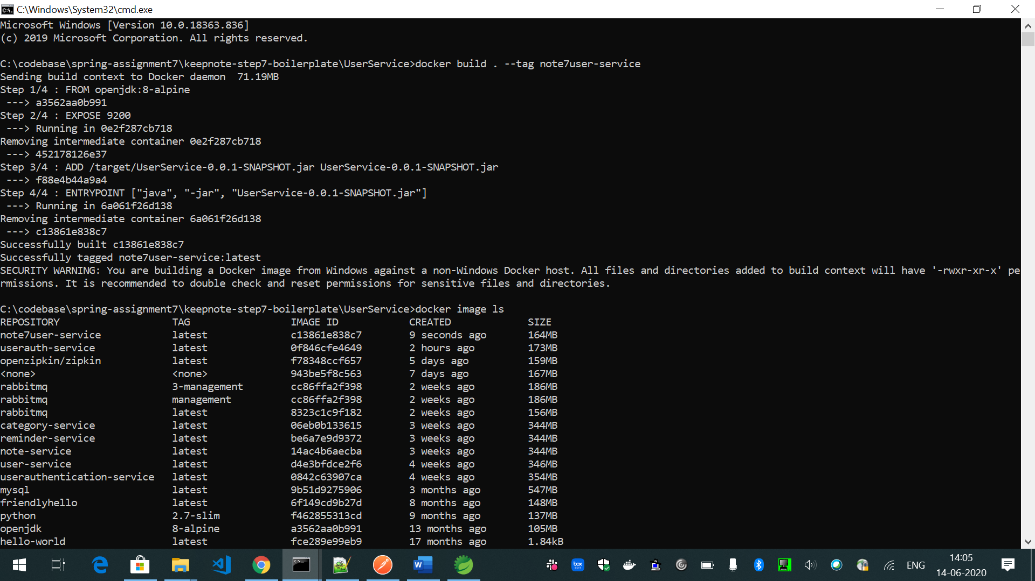

Accessing Note Creation api of NoteService through Zuul proxy:

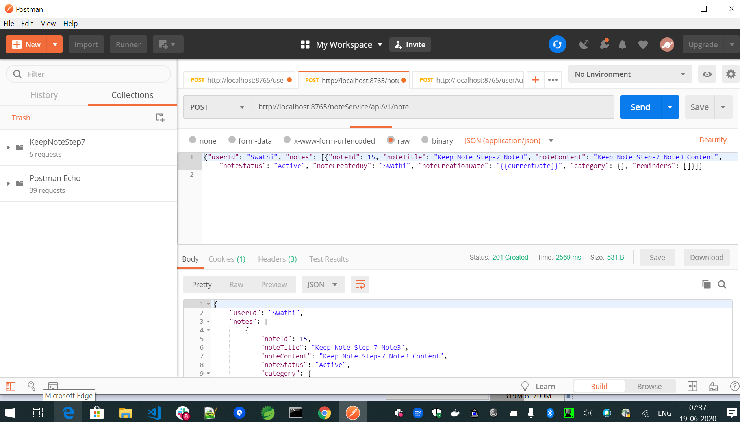

Get Notes created by user:

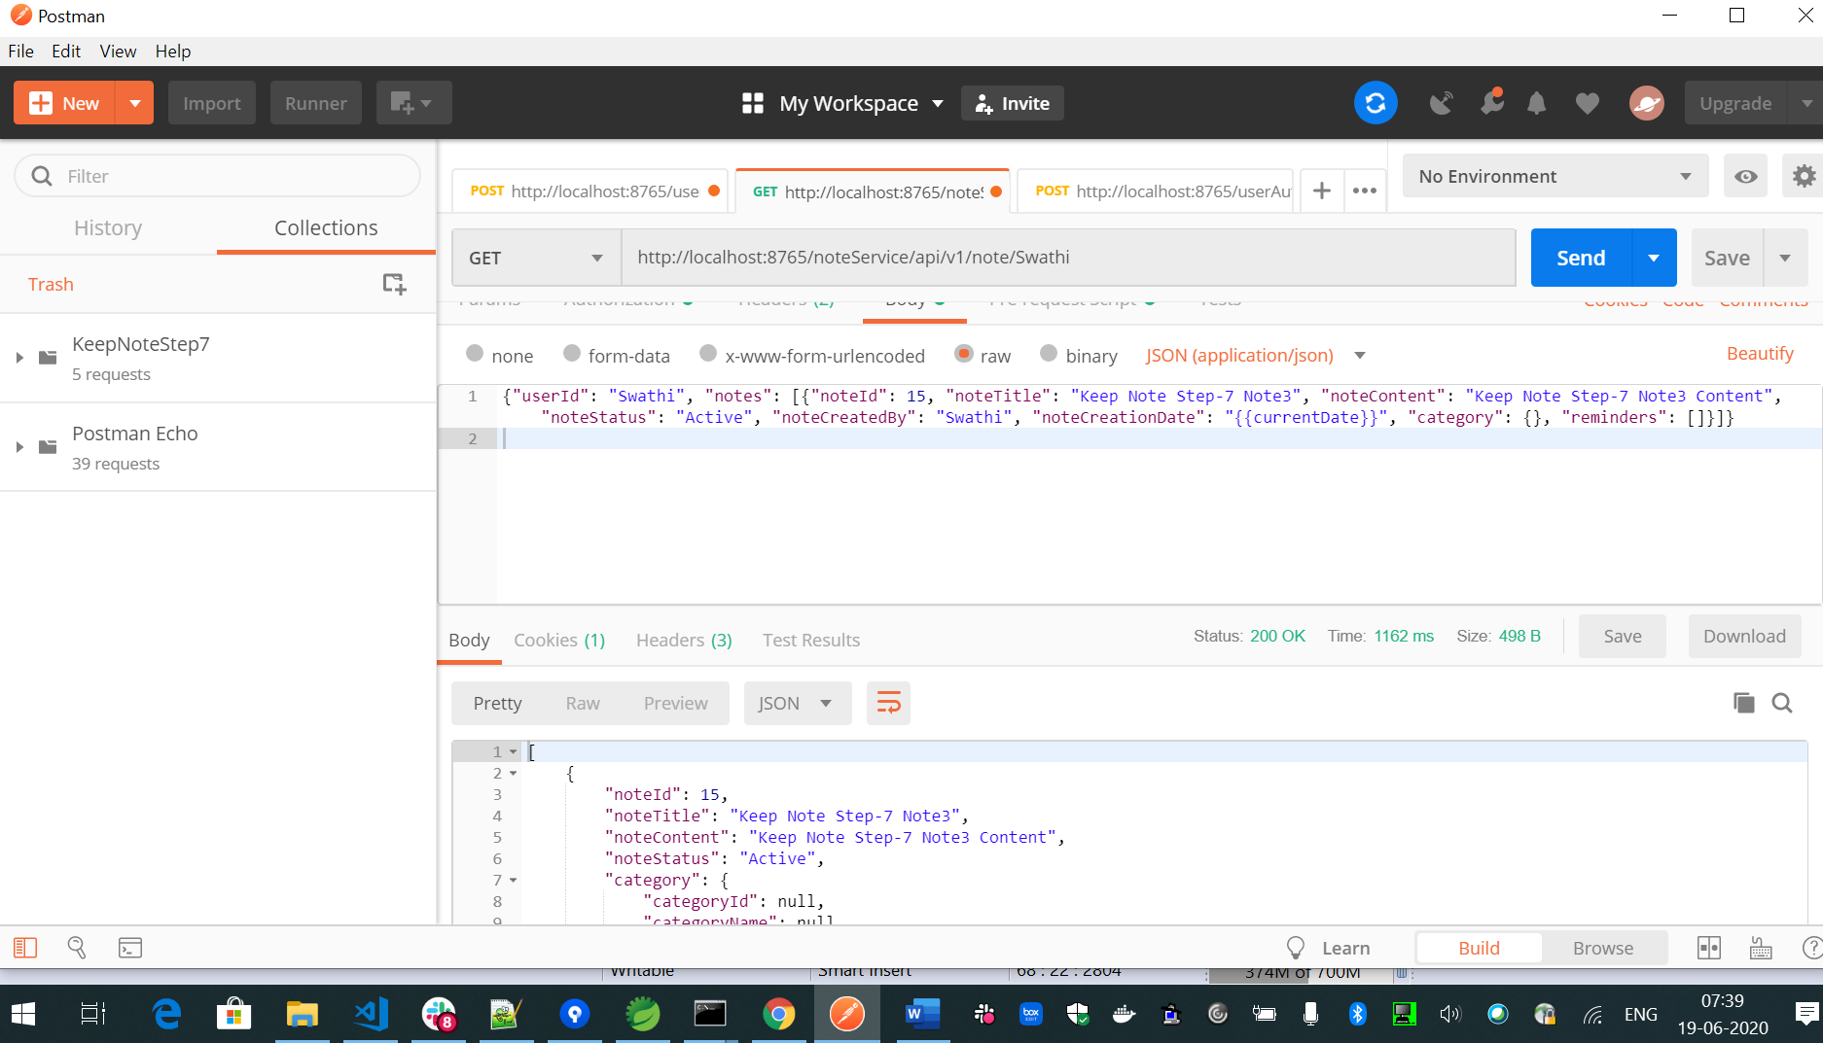

Note service docker image creation:

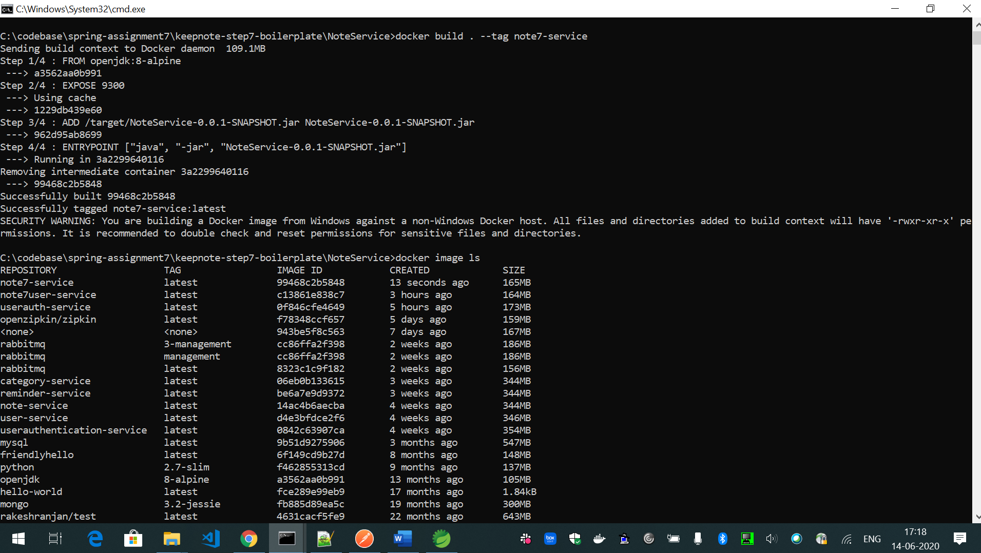

Create Category using post api of Categoryservice through zuul proxy:

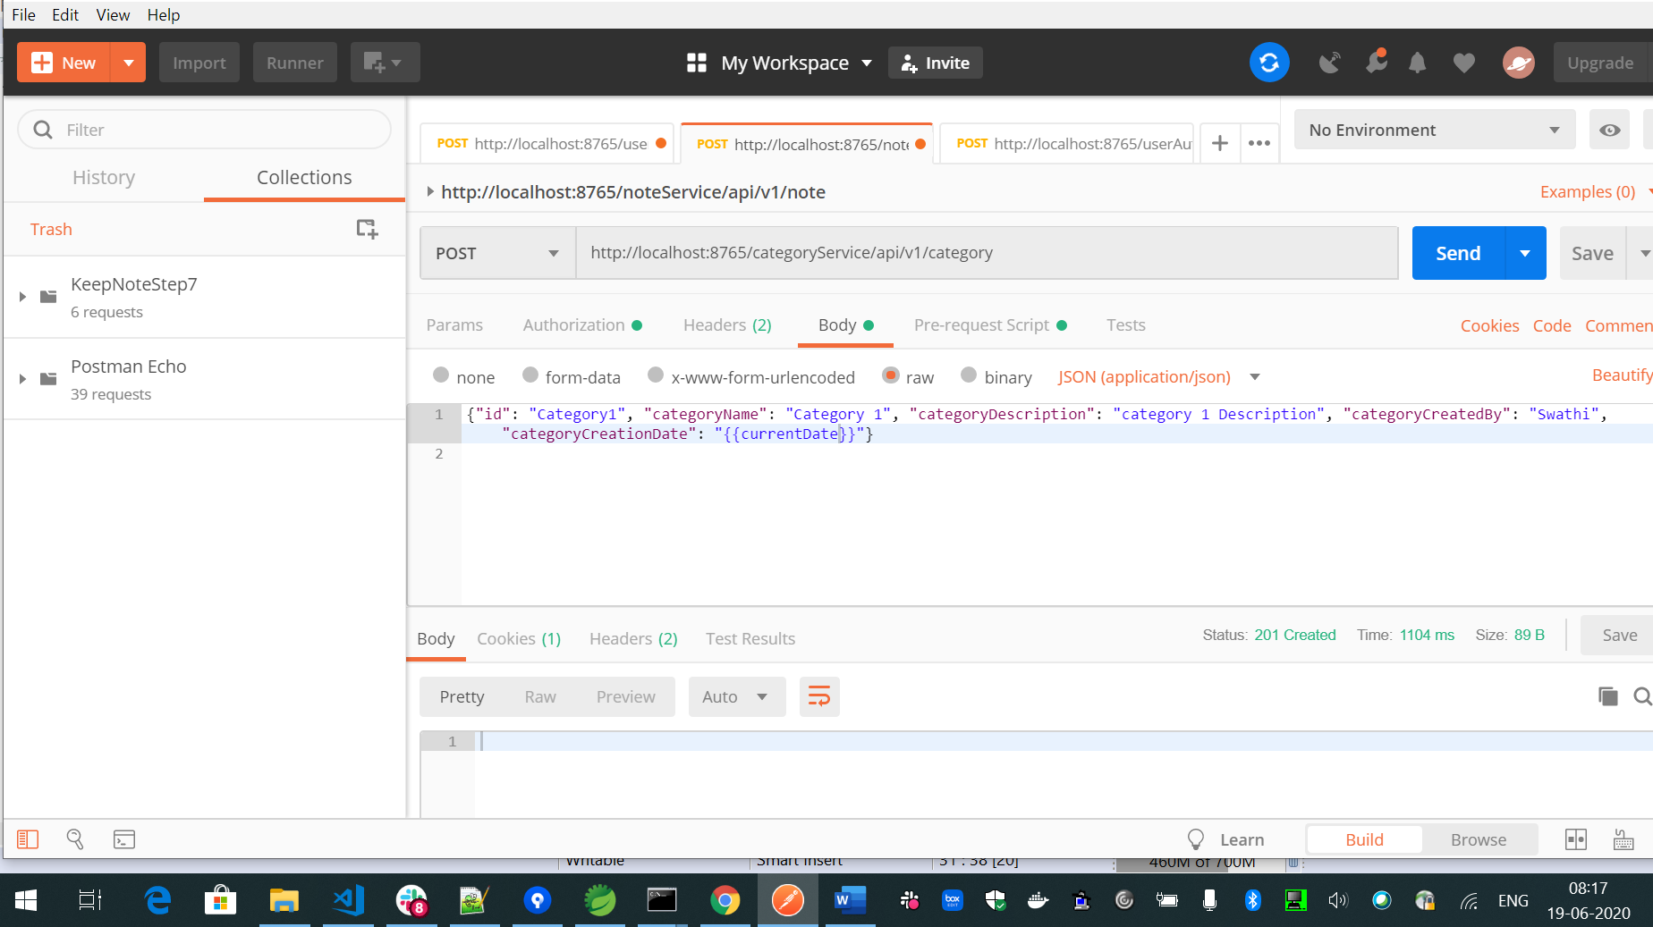

Update Category api of CategoryService through zuul proxy:

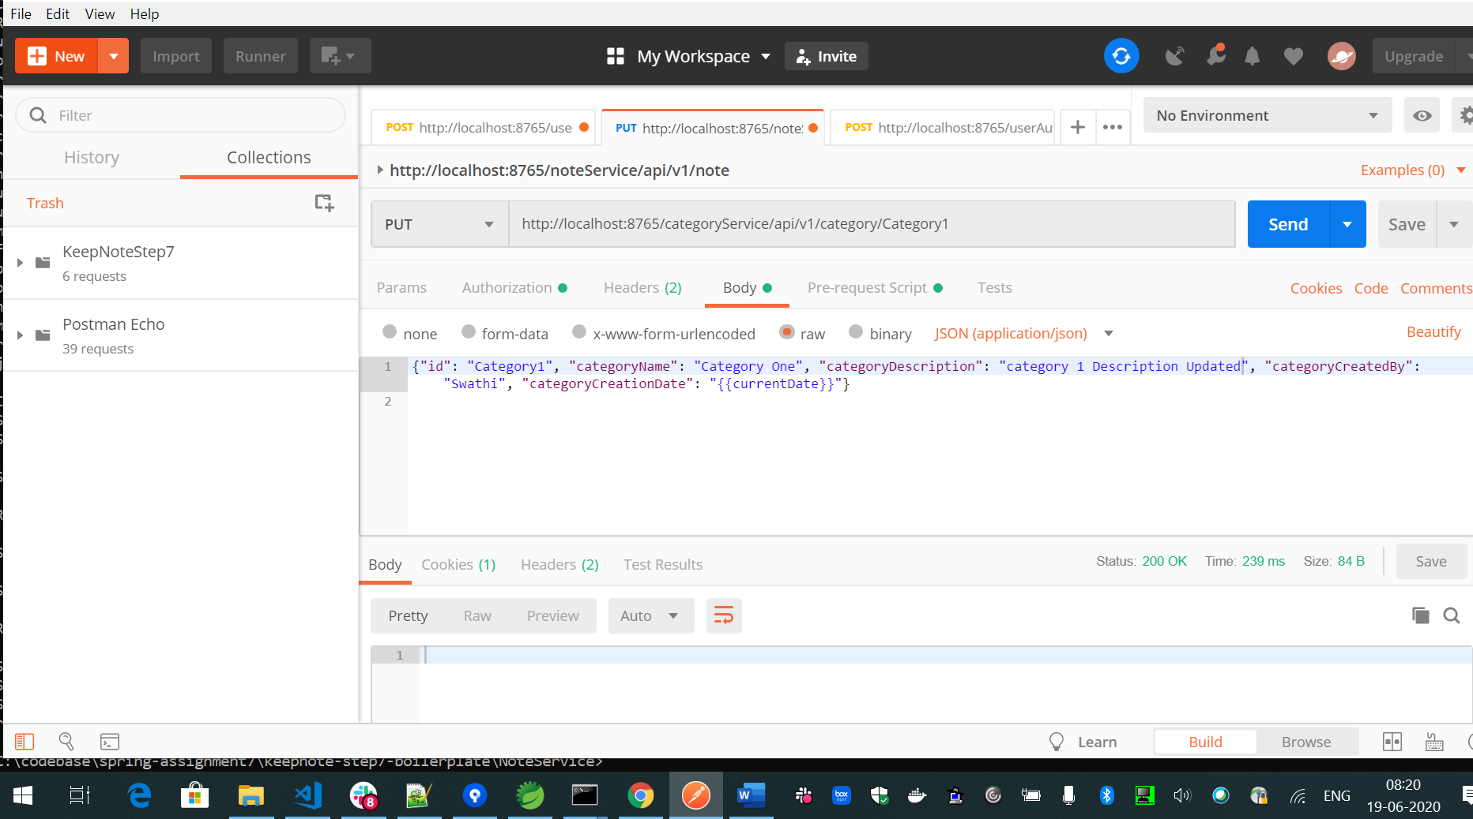

Get Category of CategoryService through zuul proxy:

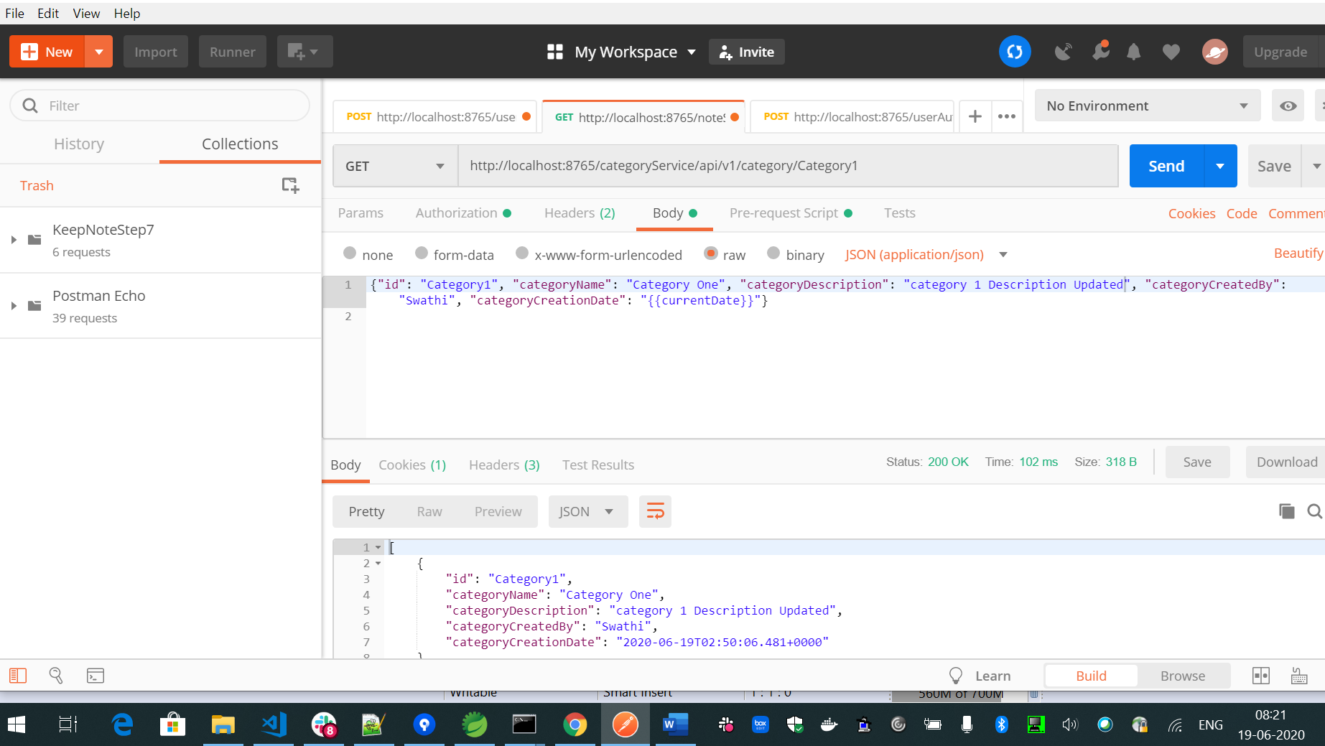

Category service docker image generation:

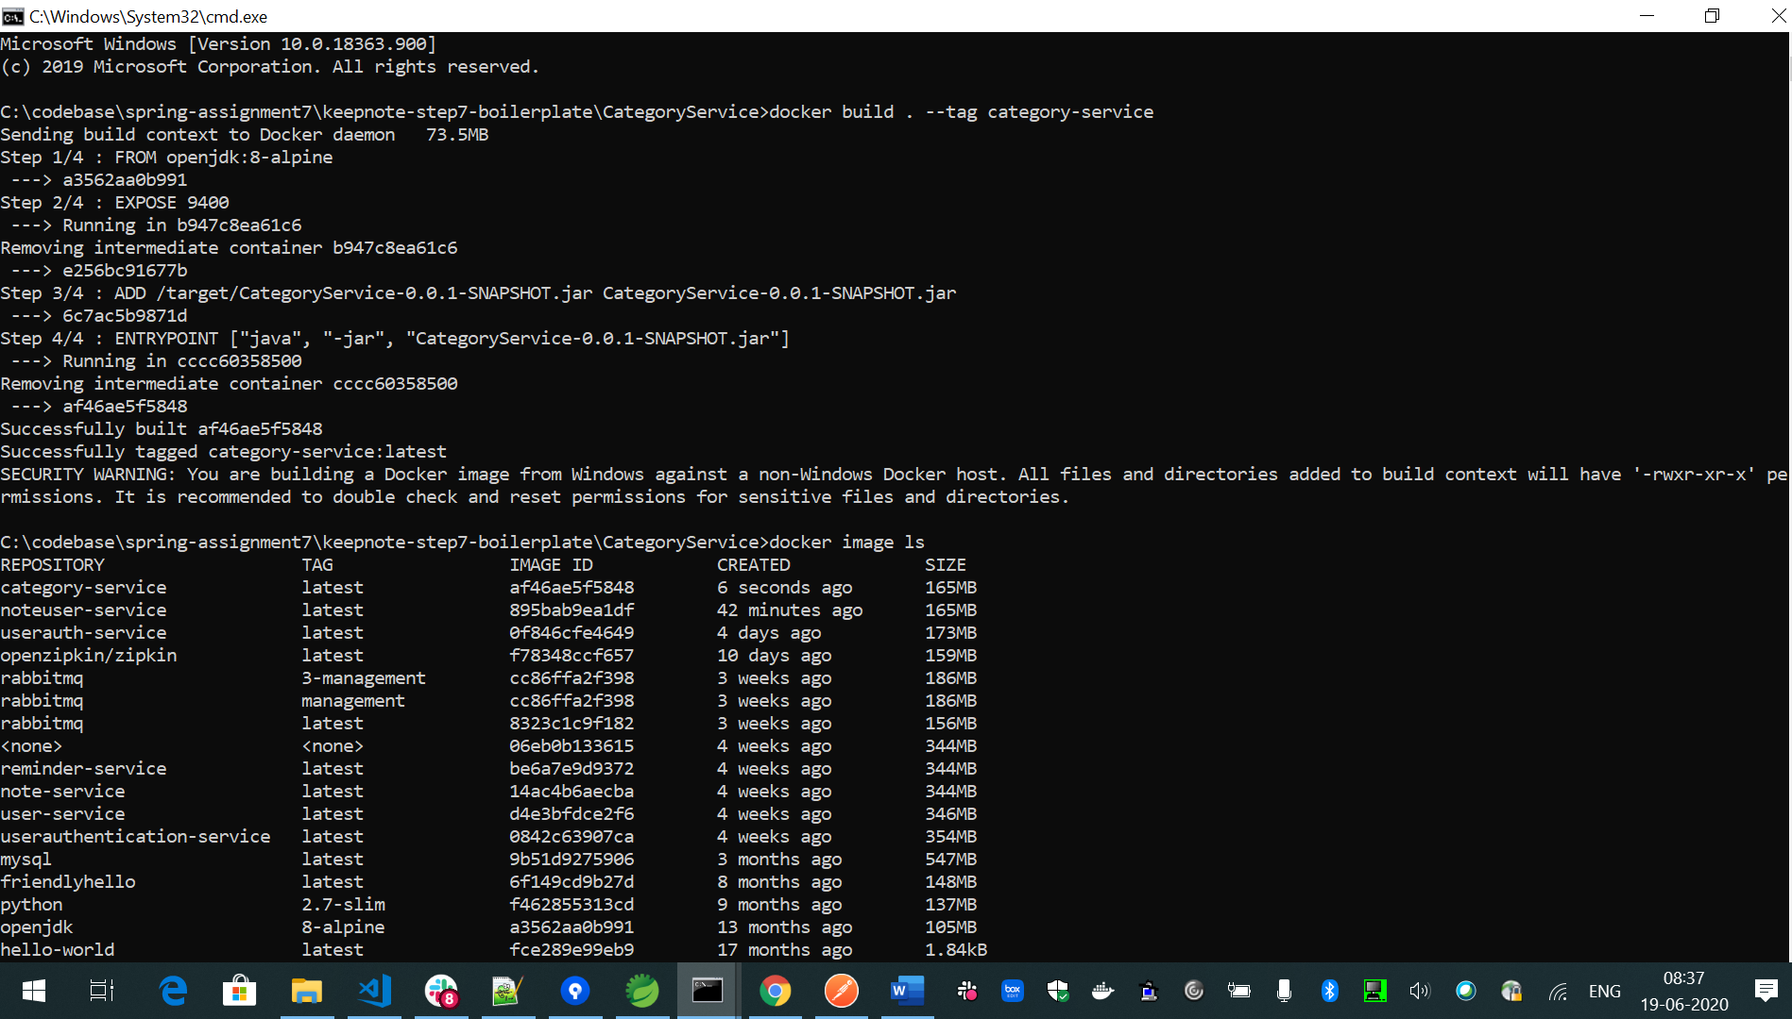

Create Reminder using post api of Reminderservice through zuul proxy:

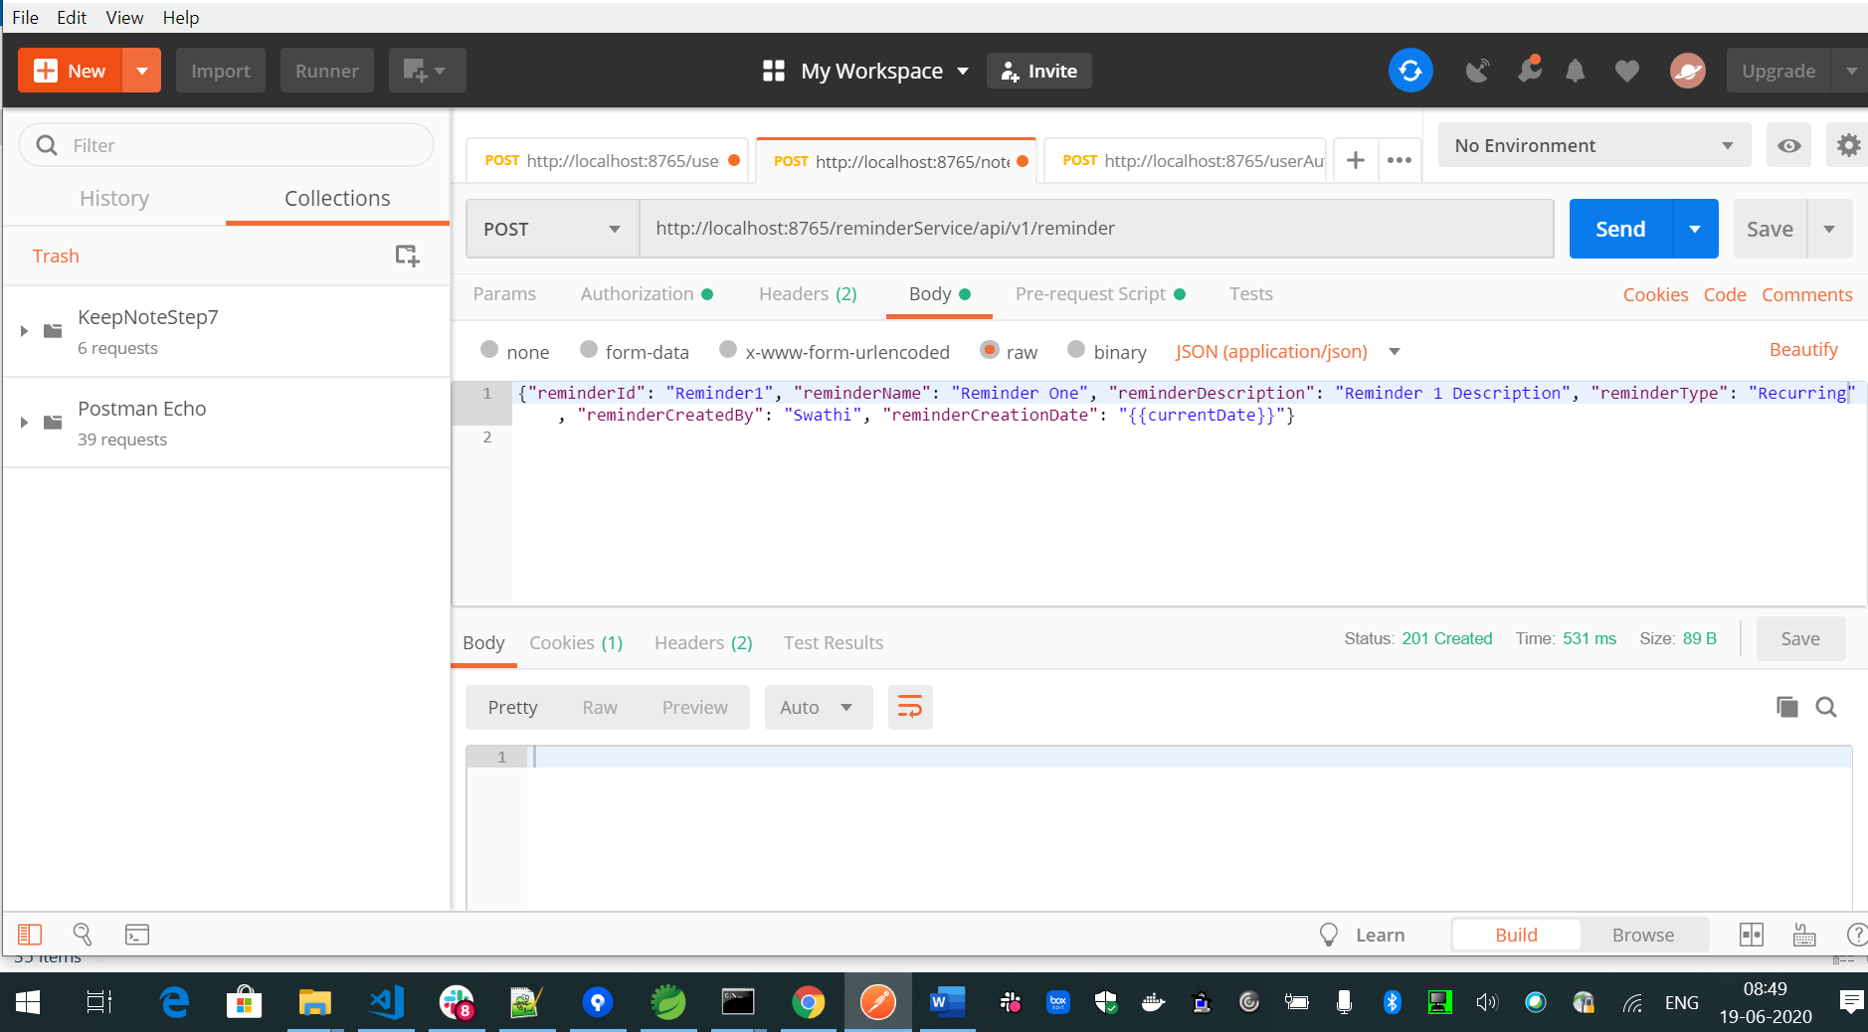

Get All reminders using zuul proxy:

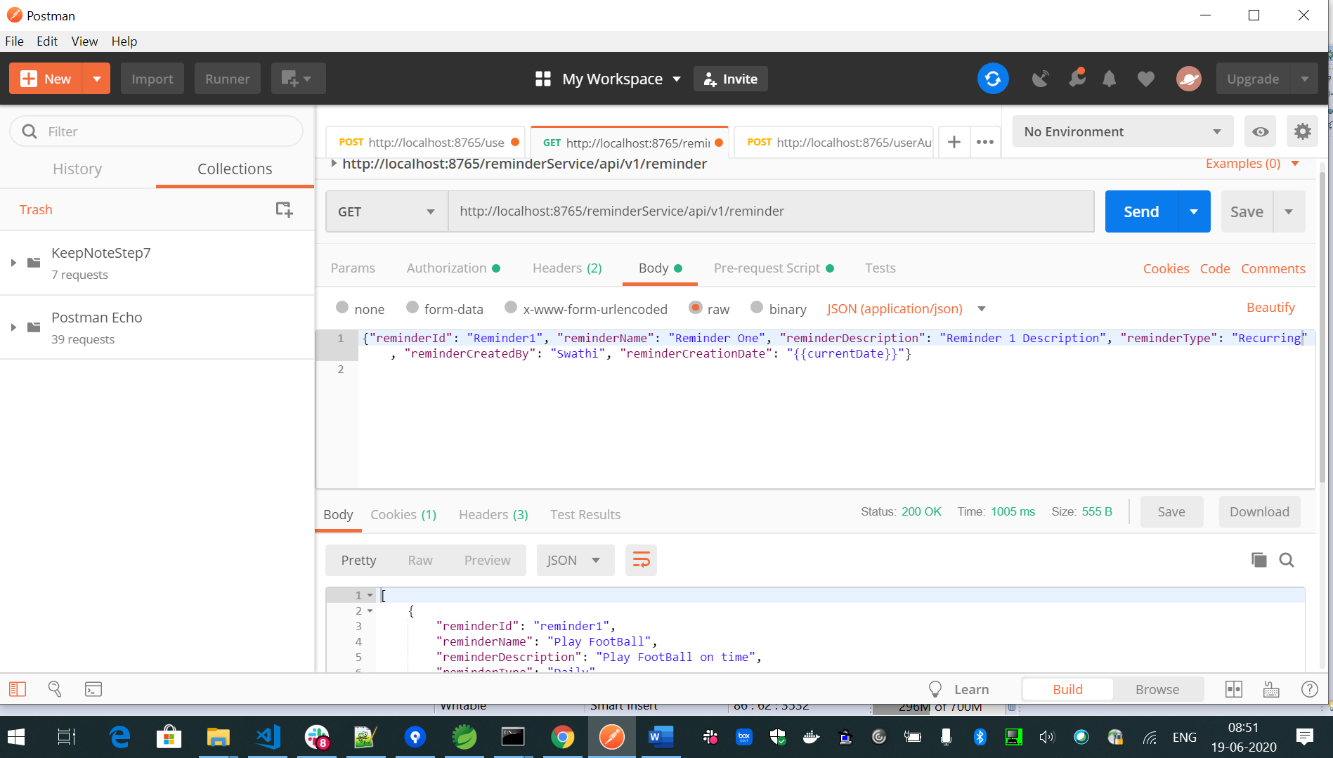

Update Reminder using zull proxy:

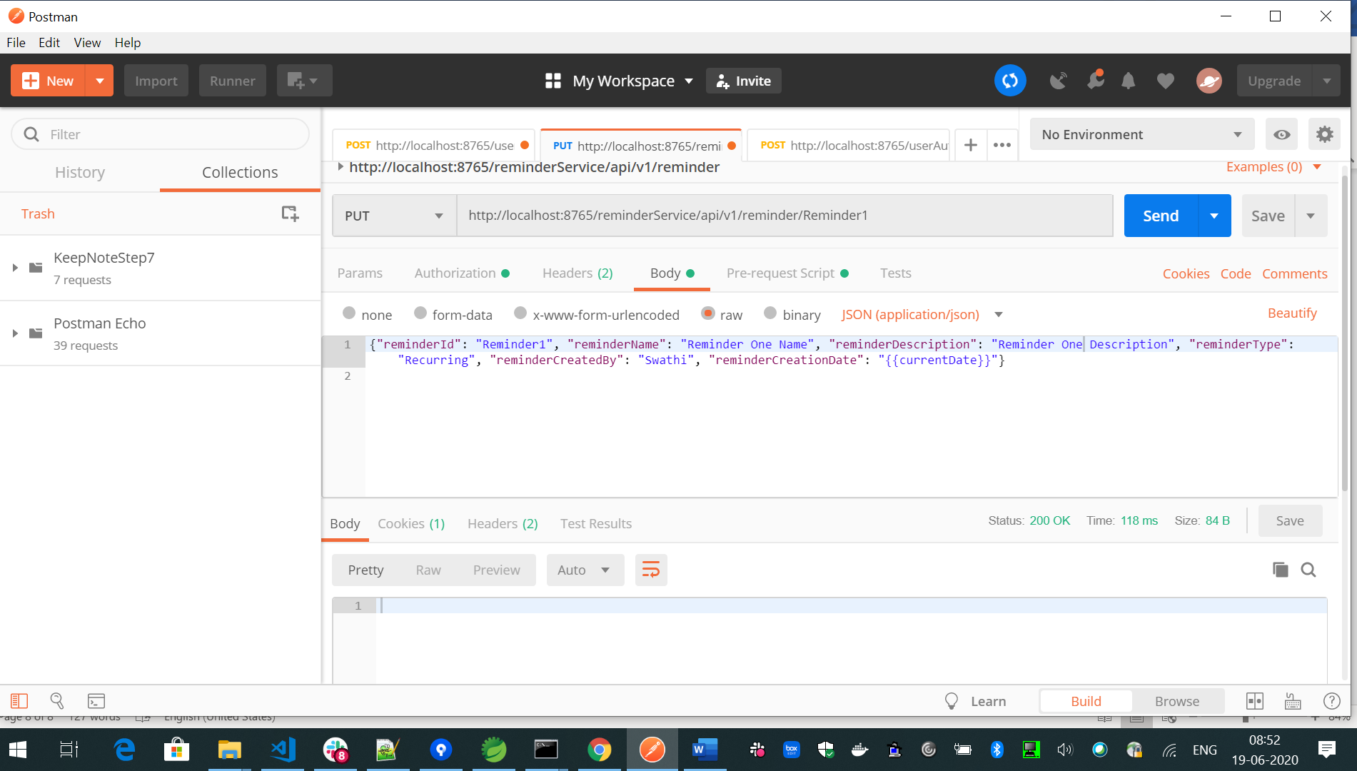

Creating Reminder service docker image:

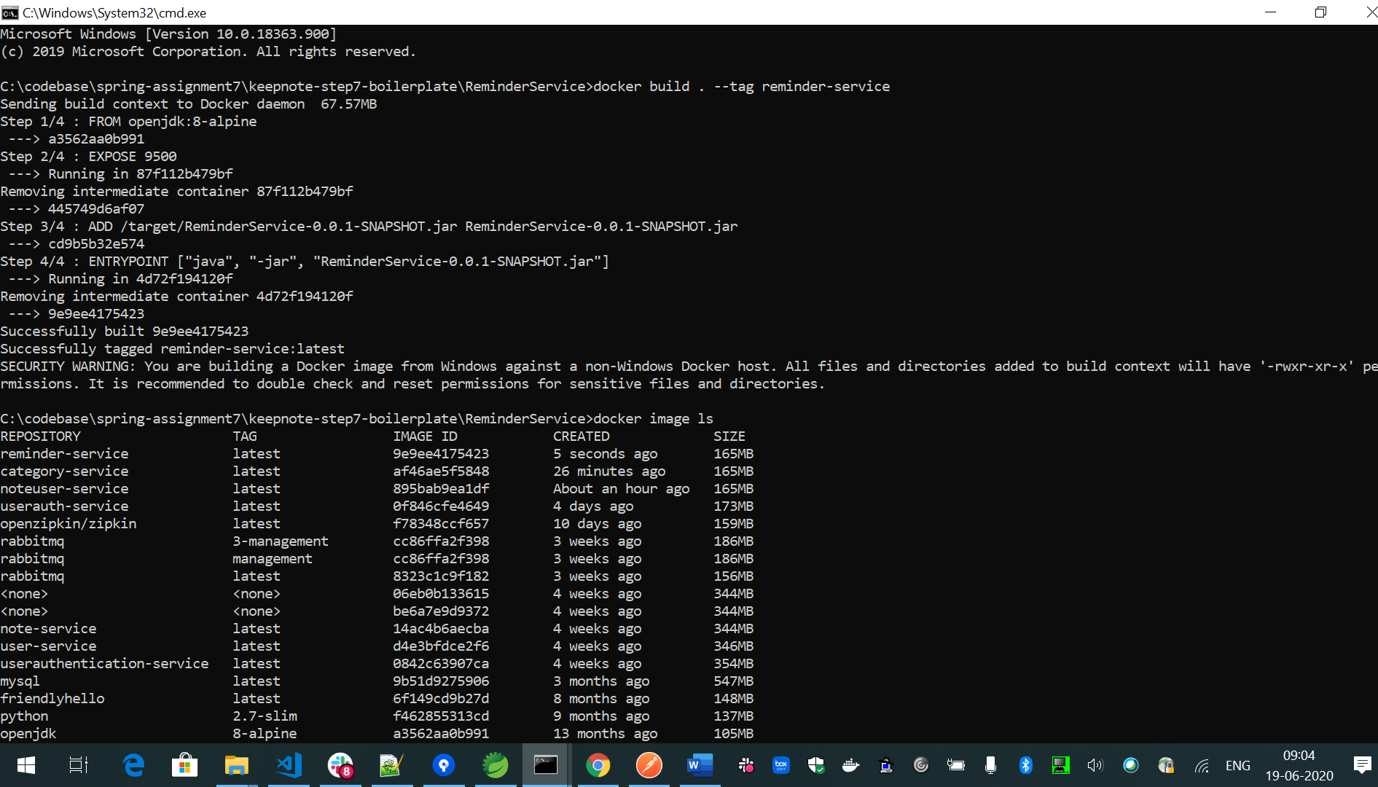

Eureka server screenshot:

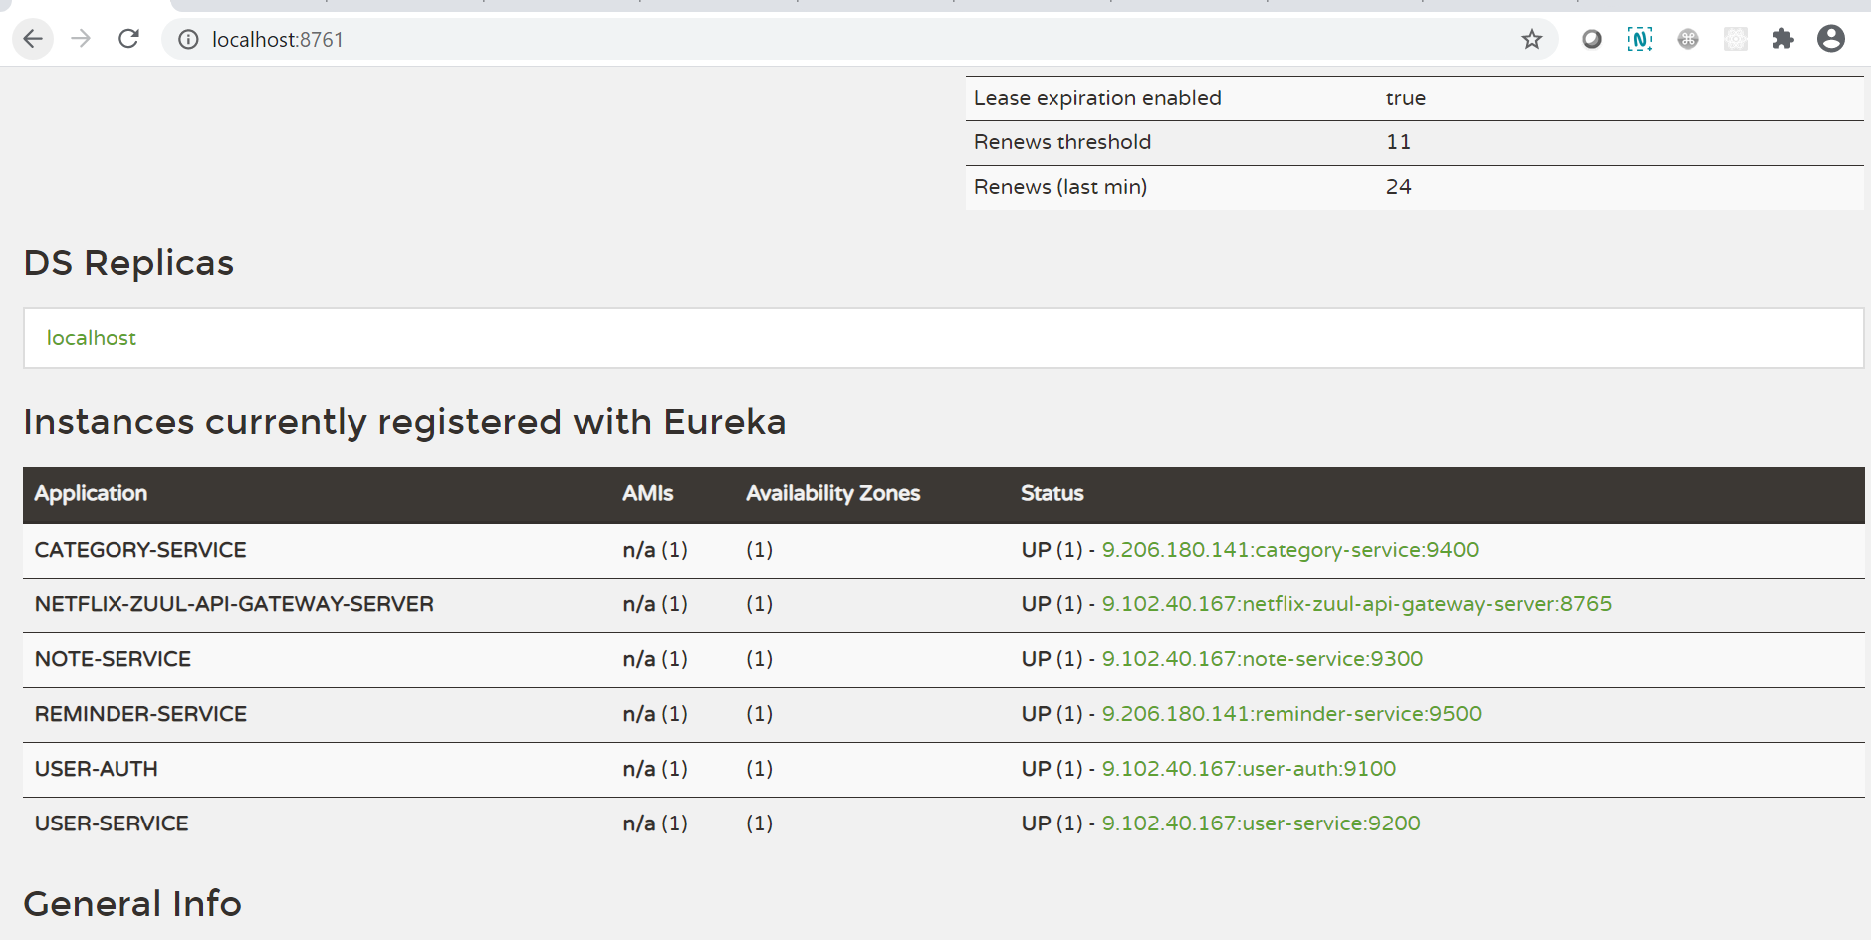

Docker compose up:

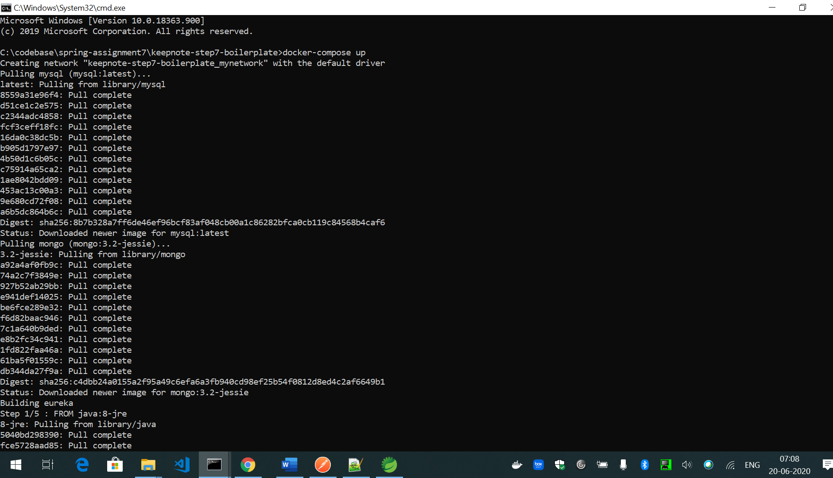

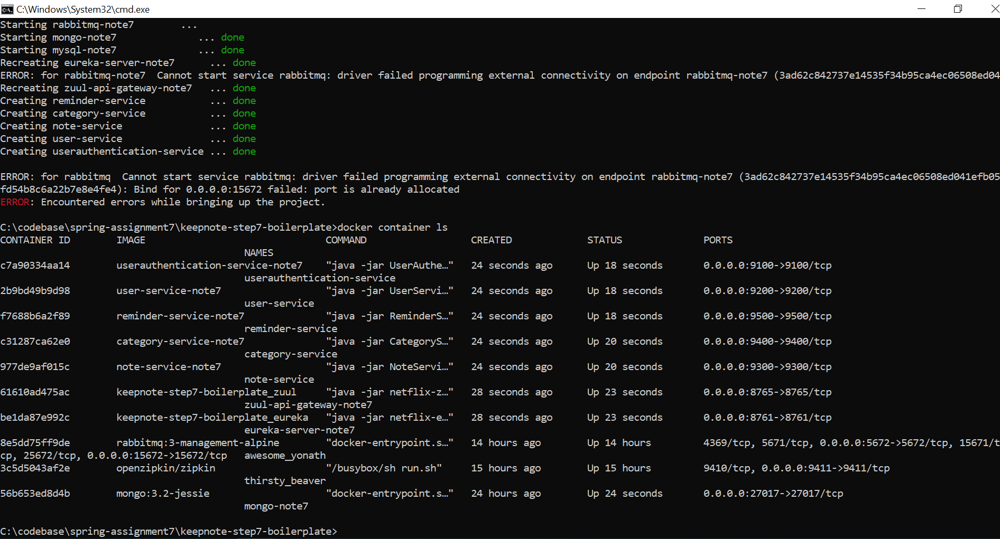

RabbitMQ Screenshot:

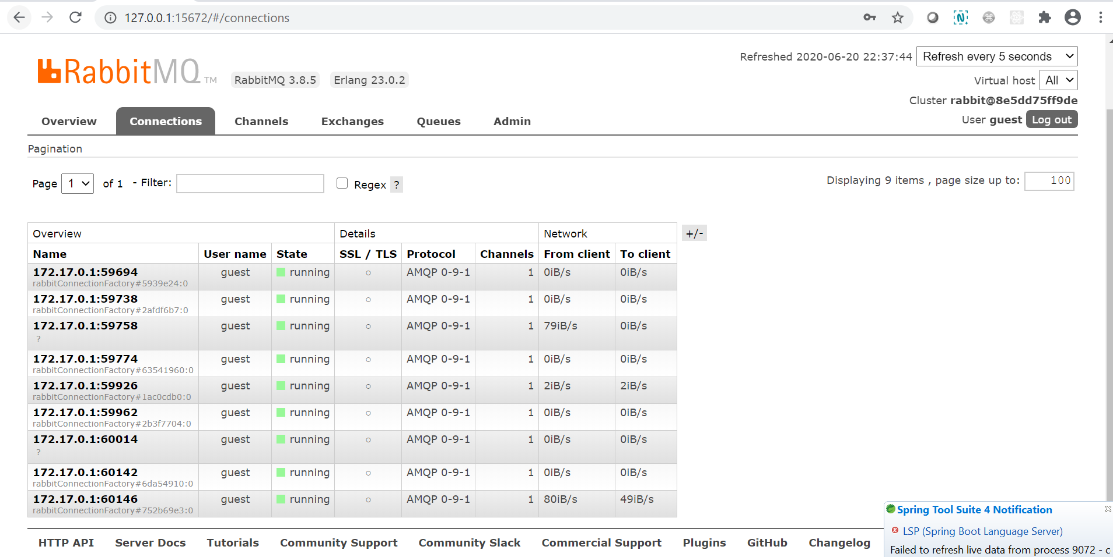

ZipKin Screenshot:

